Report on NAT Test Automation Framework

Contents
1. Executive Summary 3
2. Introduction About NAT Test Automation Framework 5
2.1 Tools/Technology Used for NAT Test Automation Framework 5
3. Overview of NAT Test Automation Framework 7
4. Architecture of NAT Test Automation Framework 9
5. Workflow of NAT Test Automation Framework 10
6. Script flow of NAT Test Automation Framework 12
7. People and Roadmap 13

Figure 1 Automation Framework Overview 7
Figure 2 Functional Testing 8
Figure 3 Automation Framework Architecture 9
Figure 4 Automation Framework Workflow 10
Figure 5 GitHub Workflow 11
Figure 6 Test Dashboard 11
Figure 7 Automation Framework Script flow 12

Executive Summary
Mosaiq platform has components either in cloud or not in cloud. The scope of this test document is to design test automation for cloud-based components (web-based and restful web services).
The product requirements are in form of user stories for which test cases are written.
Since we are not using any Test Management Tool, the test cases are designed and maintained in plain English text (called Gherkin with Given-When-Then format) on Confluence (a collaborative online documentation tool).

Manual and test automation is performed on the stories implemented by the developer. In NAT (agile process) development, the builds happen frequently. Test automation is triggered for stories in previous builds that are integrated with developer builds (these builds are release for testing and are the replica of the production build). Manual test activities are done for story(ies) (not automated or automation development in-progress) for the current developer build.
Test automation can be triggered in following ways.
- Manually, where tester/ developer can manually trigger the test.
- Scheduler, where automatic trigger happens at scheduled time
To achieve test automation in Mosaiq, NAT test automation framework is developed. It is a hybrid framework as it supports multiple frameworks and libraries. The tests are designed using Selenium (open-source java library used for browser automation) and Core Java. The test reports generated are in HTML format.
Test scripts and test automation framework code is maintained in the repository at GitHub (a cloud-based code hosting platform for version control and collaboration). Build tool, Gradle is used for build management and test execution engine.
The test environment is docker based (virtual software platform that simplifies the process of building, running, managing, and distributing applications) and has no dependency on any specific system to execute the test.
Github contains a tool, GitHub actions (cloud based continuous integration and continuous delivery platform that allows to automate a build, test, and deploy) in which workflow (series of actions to be performed in sequential way) is designed to automate the test process.
Github action performs the following actions sequentially:
- Pulls the latest docker image
- Triggers the functional test
- Generate the test artifacts
- Copies them to AWS (cloud-based storage)
- Publish the test data for Dashboard
The dashboard data accessible for team members for further analysis. Additionally, test summary with link to test report are logged in Jira (project management and issue tracking software).
Test automation helps in reducing the time for execution of regression test. At present (for NAT), test automation is done for 53 user stories that include 328 functional and 39 restful web services test cases. The execution time of regression test for functional scenario is 1 hour (vs manual duration 1 week) and restful web services is 5 min (vs. manual duration 1 day).

Current Regression Test Summary is as below:
Engineering  Tools | Total Requirements | Total Number of Test Cases | Requirements Automated | No of Test Cases Automated | No of Test cases Not Automated | Test Automation % | Test Coverage %

Introduction About NAT Test Automation Framework

NAT Platform Services is a web-based application developed using technologies like React, AXON Server, Java, HTML5, Spring Boot and AWS.
QA team of Platform Services developed NAT Test Automation Framework which uses latest technologies & frameworks to test and automate these web services and web applications.
This is an agile based development and follows Continuous Integration, Testing and Deployment. Hence, deployment, testing and release are automated processes.
Team has designed build, test and deployment systems which performs Continuous Integration, Continuous Testing and Continuous Deployment automatically.

Tools/Technology Used for NAT Test Automation Framework
QA Team of NAT Platform Services uses latest technologies and framework to design and test the product. To automate different Test Automation types, QA team have identified various tools and frameworks which is highly ranked and valued as per current market trends.
- Selenium
It is an open-source umbrella project for a range of tools and libraries aimed at supporting browser automation.
- Rest Assured
It is a java library used for testing and validating the Restful Web Services. It supports Behavior-Driven Development (BDD) syntax like Given, When, and Then notations. It helps us to integrate with testing frameworks like Junit or TestNG.
- Serenity BDD with Screenplay
It is a framework and open-source library for the creation of automated software testing for code in development. Like other automated testing tools, Serenity BDD is made to smooth development by catching bugs sooner and helping ensure the release of a stable, fully functioning end software product.
Screenplay, introduced in Serenity BDD, aims to encourage good testing habits and well-designed test suites by enabling teams to write more robust and reliable tests. It is based on the Selenium WebDriver and the Page Objects model.
- Cucumber
It is a software tool that supports behavior-driven development. Central to the Cucumber BDD approach is its ordinary language parser called Gherkin. It allows expected software behaviors to be specified in a logical language that customers can understand.

- Core Java
It is a part of the Java programming language that one can use for developing or creating a general-purpose app. Its focus is to build such general applications. The J2SE (Java Standard Edition) is known as Core Java. It mainly covers concepts of object-oriented programming (OOP).
- Gradle
It is a build automation tool for multi-language software development. It controls the development process in the tasks of compilation and packaging to testing, deployment, and publishing. Supported languages include Java, C/C++, and JavaScript.
- Maven
It is a build automation tool used primarily for Java projects. Maven can also be used to build and manage projects written in C#, Ruby, Scala, and other languages. The Maven project is hosted by the Apache Software Foundation, where it was formerly part of the Jakarta Project.
- Git Hub Actions
It is a continuous integration and continuous delivery (CI/CD) platform that allows you to automate your build, test, and deployment pipeline. You can create workflows that build and test every pull request to your repository or deploy merged pull requests to production.
- JavaScript
It is a programming language that is one of the core technologies of the World Wide Web, alongside HTML and CSS. Over 97% of websites use JavaScript on the client side for web page behavior, often incorporating third-party libraries.
- NodeJS
It is an open-source, cross-platform, back-end JavaScript runtime environment that runs on the V8 engine and executes JavaScript code outside a web browser.
- Docker
It is a set of platforms as a service product that use OS-level virtualization to deliver software in packages called containers. The service has both free and premium tiers. The software that hosts the containers is called Docker Engine.
- AWS
It is a subsidiary of Amazon that provides on-demand cloud computing platforms and APIs to individuals, companies, and governments, on a metered pay-as-you-go basis. These cloud computing web services provide distributed computing processing capacity and software tools via AWS server farms.

Overview of NAT Test Automation Framework
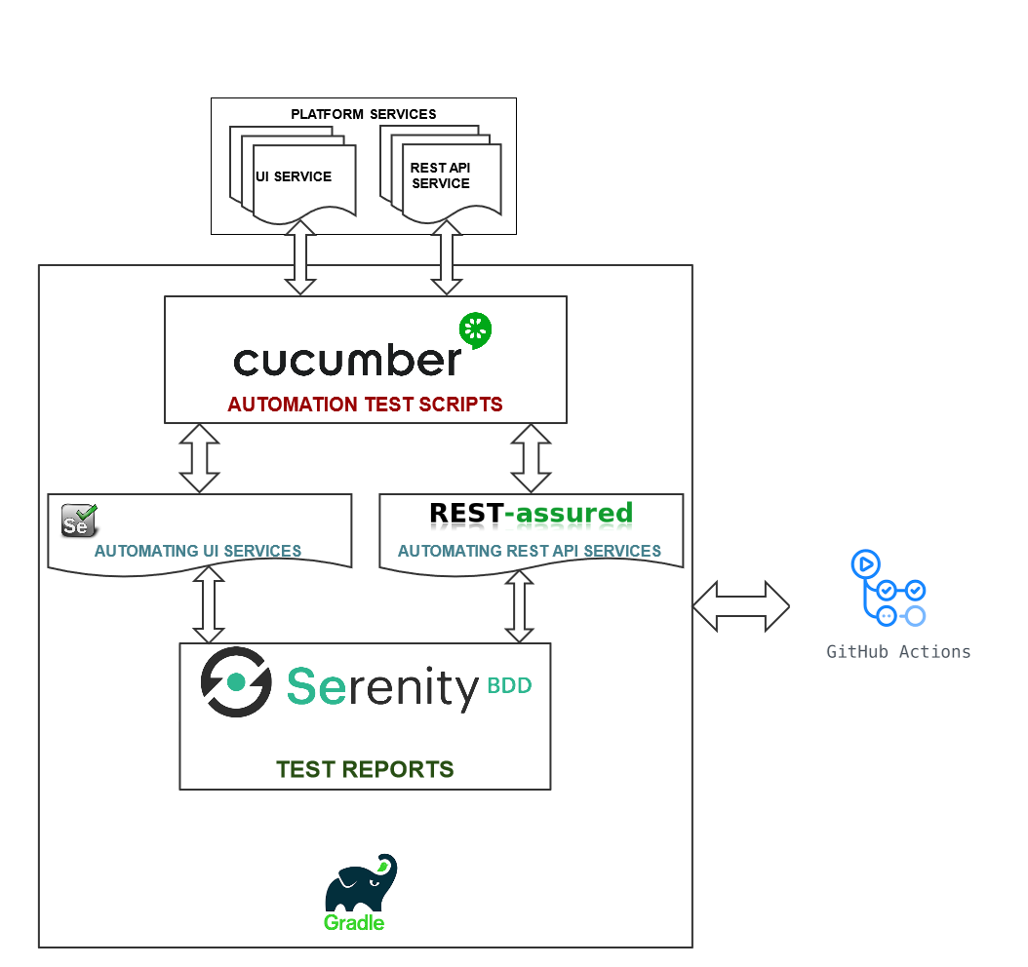
Figure 1 Automation Framework Overview

The above model displays explain the functional test automation high level architecture.
FUNCTIONAL TESTING is a type of software testing that validates the software system against the functional requirements/specifications. The purpose of Functional tests is to test each function of the software application, by providing appropriate input, verifying the output against the Functional requirements.

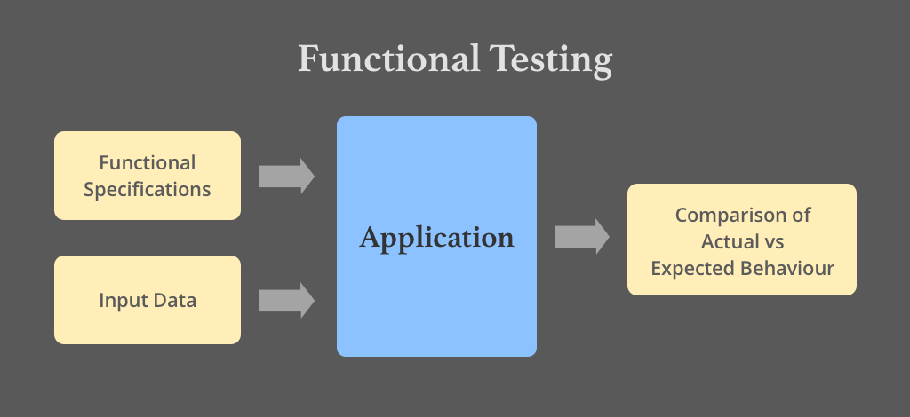
Figure 2 Functional Testing

Now referring to our original functional test automation architecture, under functional test we verify two major application types

- Web User Interface – Verification of dynamic/static functionalities implemented through the User Interface.

- Rest based Web API – These API act as an interface between backend and frontend. Here we basically verify the data received (provided by the backend through these API)

Functional tests are written and maintained in Gherkin language, for which we are using a tool called Cucumber. As per Gherkin standards, each requirement is covered as a feature and every feature contains multiple scenarios and user data.
The steps defined in feature file is mapped with a java class, and this java class will refer the required objects (frontend elements) and libraries (front-end and rest api)
Serenity is as a BDD based test-automation framework which is used to test both frontend and Rest API. Serenity automatically collects the test data and creates a HTML based test-report.
Gradle is a driver which triggers these tests by calling a java based main() class.
The main() class initializes & executes the tests and creates the test-report.
As a part of CI/CD initiative, GIT-HUB Action will automatically trigger these tests, collects the test-artifact and copies them on the AWS.

Architecture of NAT Test Automation Framework

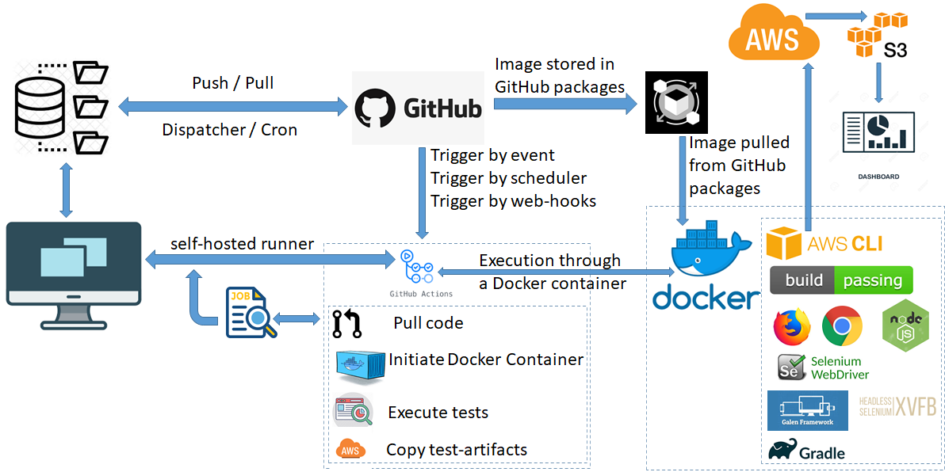
Figure 3 Automation Framework Architecture

The above model explains the test automation architecture designed for Platform Services.
QA team maintains the test automation framework code and test scripts in repository maintained in GitHub.
GitHub also stores a test infrastructure docker image under GitHub package.
The docker image contains the required test environment (browsers, frameworks, libraries, and build & test engine) to launch and perform automated testing.
The repository contains a workflow which is called by GitHub to trigger the set of actions defined under the workflow.
In case of Platform Services once the workflow is triggered:

- The latest code is triggered
- Docker Container is Initialized
- Tests are executed
- Test Artifacts generated during execution are copied to AWS
A test system needs to associate with a workflow which can be either a Virtual system hosted at GitHub / AWS or it can be a local hosted system connected with GitHub through Self-Hosted Runner.
Self-Hosted Runner is a GitHub Service which needs to be configured on the system required to be connected with GitHub. When the service is running on the system GitHub can identify the system and can perform the execution of the workflow on it.

Workflow of NAT Test Automation Framework
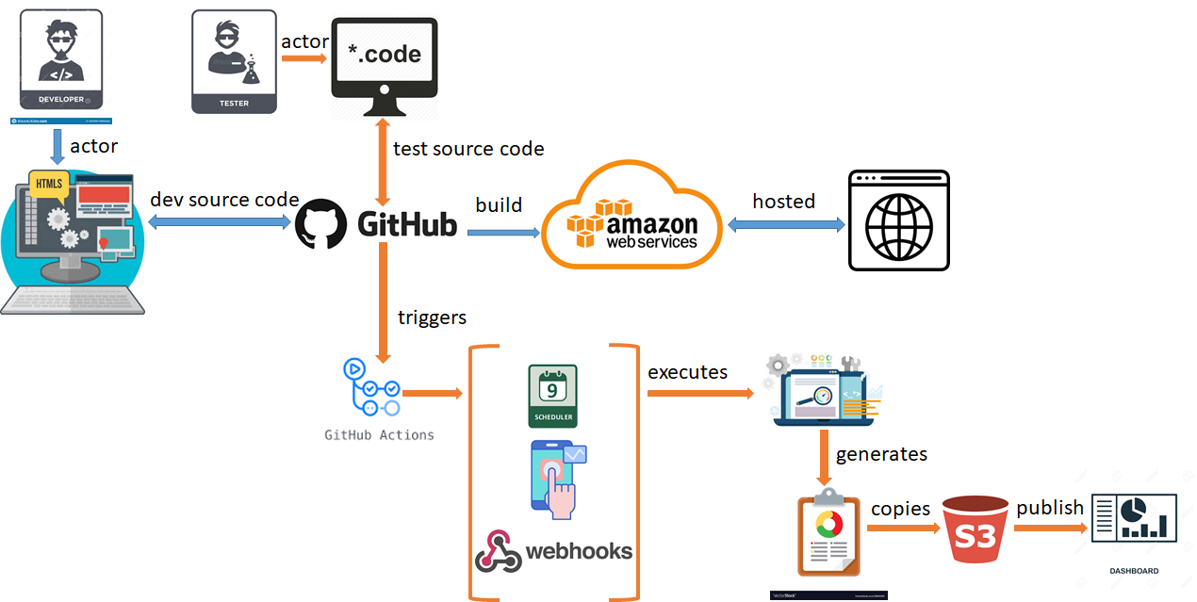
Figure 4 Automation Framework Workflow
The above model explains the workflow of test automation when QA team develops and integrates the automated test-scripts with the framework.
Test Automation can be triggered by 3 ways:

- Manually: This is an on-demand approach where any member from QA / Developer can manually trigger the test-automation by clicking the <Run workflow> from the GitHub Actions.
- Scheduler: This is a scheduled approach where workflow will get triggered automatically at a scheduled day and time.
- Webhooks: This is also an on-demand approach but more in lines with Continuous Testing and Integration approach. Webhooks are customizable GitHub action rest API which user can integrate with its workflow to trigger an external workflow. This means a developer can integrate a Webhook in its workflow process. Once the code is developed, compiled, build and successfully deployed, the development workflow can trigger the test-automation workflow. If the tests are successful, then code will get merged with Master branch else a defect will get raised and merging of code in Master branch will not happen.
Developer develops the code and merge it in the repository hosted at GitHub. This code gets compiled, build, and deployed in AWS.
QA team develops the test-scripts and merge it in the repository hosted at GitHub. Same repository also maintains the Test Automation Framework code.
GitHub contains a tool known with a name GitHub action. This tool is used to automate the build, deploy, and test processes. To automate a process through GitHub action, GitHub repository should be configured with a Workflow. Workflow defines Step and every Step is associated with some desired action.
A screenshot of an executed GitHub action workflow for reference has been provided. This will show you the execution flow of Steps with desired Actions designed inside the workflow.

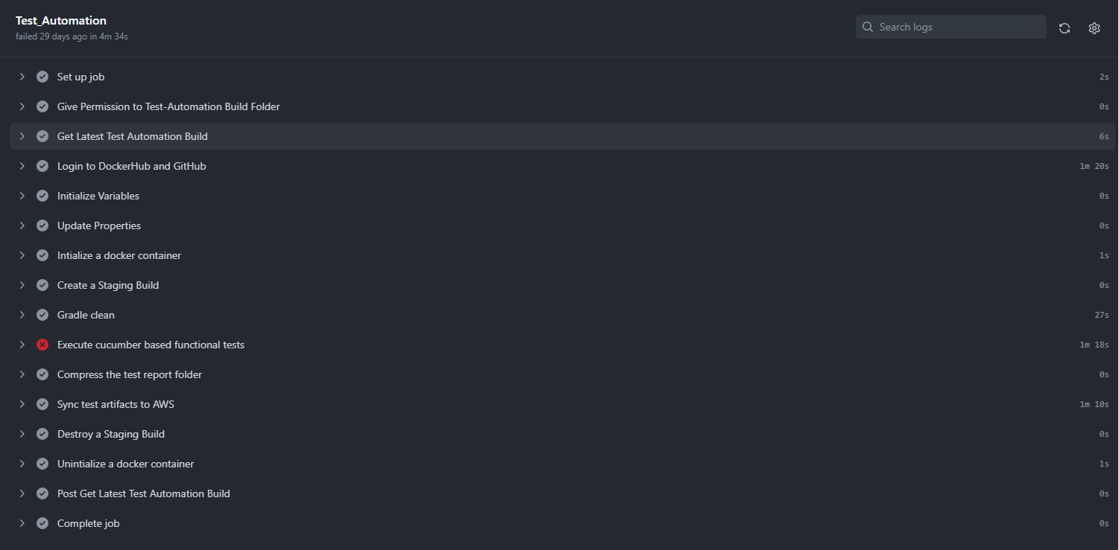
Figure 5 GitHub Workflow
GitHub Action triggers the functional tests -> Generates the Test Artifacts -> Copies the Test Artifacts to AWS -> Publish the Test Data for Dashboard

A screenshot of Dashboard has been provided for reference. The Dashboard publish test data for all the NAT projects which also includes Platform Services.

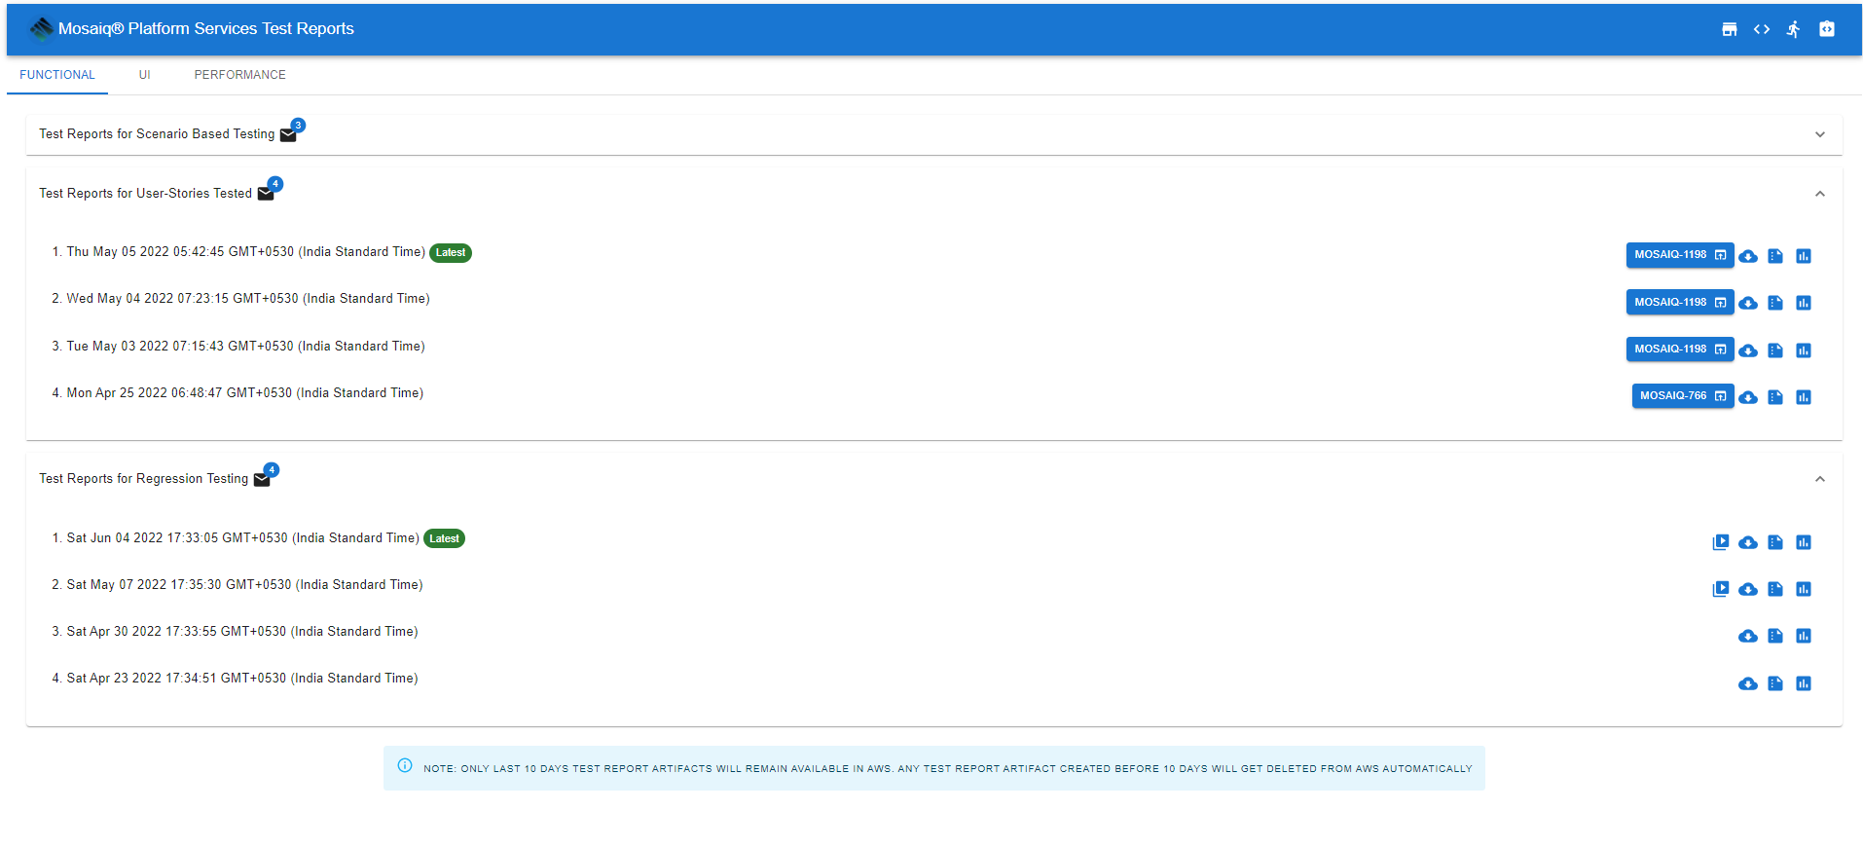
Figure 6 Test Dashboard

Script flow of NAT Test Automation Framework

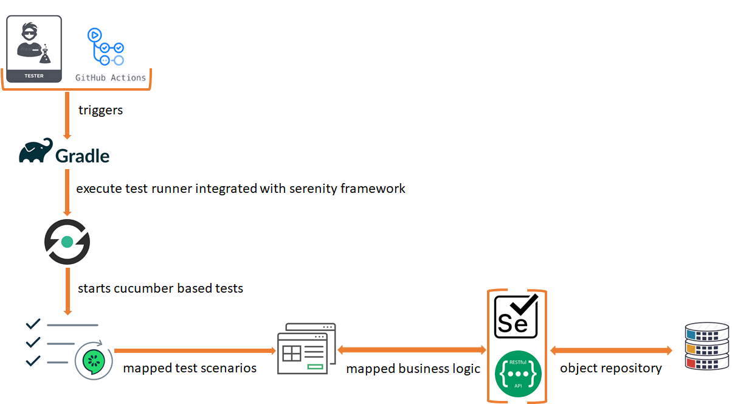
Figure 7 Automation Framework Script flow

The above model explains the execution flow of functional automated test-scripts once triggered by Github Action.

Gradle is a test engine which triggers the main / test runner class from the framework. The runner class will initialize the Cucumber based feature file. Each feature file will be mapped with its relevant java class which maps defined test steps in cucumber with its relevant java function. Every mapped java class will refer business logic and object repositories.

The mapped java classes are not tightly coupled with each feature file. In fact, these mapped java classes are loosely coupled and can get mapped with multiple feature files hence, making it flexible and shareable.

Same execution model is applicable to perform the frontend (functional) and rest API testing. Such approach gives QA team flexibility to either develop test scripts only for frontend requirements (functional) or rest API using the same framework. Additionally, QA team can develop test scripts which can combine frontend requirements (functional) and rest API.

The test report generated will combine the results of both frontend (functional) and rest API.

People and Roadmap
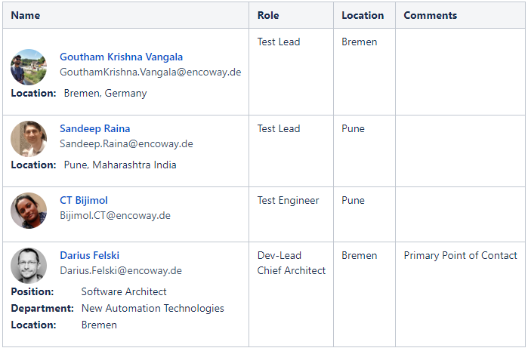
QA team will keep extending the test coverage of Functional Automated Test-Scripts. But there are other exciting things that will be developed, Integrated, and deployed.

- Introduction of Performance requirements
- Introduction to Selenium grid
- Introduction to WebDriver Manager 5
- Development of Automated Performance test-scripts using Taurus along with JMeter Framework
- Integration of Selenium grid with test environment docker image
- Integration of WebDriver Manager 5

